**TOUR THE VATICAN**

MCj04062880000[1]

Go to:

<http://www.virtualsweden.se/projects/peters/>

* Travel through 3 of the 12 sites
* Be sure to view the ceilings
* Click on the map in the upper left hand corner to return to the main menu after viewing an area.

Sistine Chapel Frescos

Go to:

<http://mv.vatican.va/index.html>

* Click on the “English” link
* Go to Online Tour (right hand side)

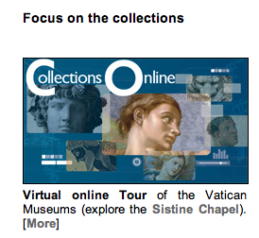

* Click on “explore the Sistine Chapel” for the 360-degree view. Be sure to view the ceiling!
* Click on “More” for an explanation of the frescos of the Sistine Chapel

Name:

Period:

Date:

Renaissance Art Webquest

Your task is to view both of the websites above and answer the following questions.

1. Renaissance artists broke from the past in several key ways. What makes these two examples of Renaissance art different from the art of the middle ages?

2. What is the main theme of the paintings, designs, architecture, and frescos?

3. Who painted the Sistine Chapel?

4. At the Entrance of St. Peter’s Basilica, what kind of architecture is represented on the front of the building? (What kind of culture does this remind you of?)

5. In the Sistine Chapel, the ceiling is made up of a series of scenes from the Bible. Name one.

6. In what city do these two buildings sit in?

7. Which website was your favorite?